MA STEEL
ACN 109 626 280
3285 Moppity Road
PO Box 163 YOUNG NSW 2594
Ph (02) 6382 4387 F (02) 6382 4373

STATEMENT OF ENVIRONMENTAL EFFECTS
DESCRIPTION | 9 x 16 x 4 mtr all colourbond garage/shed with 4 x 16 lean to (open)
PROPERTY ADDRESS | 5 Cherry Close Bendick Murrell 2803
LOT/DP | 3/-/DP1258905
APPLICANT/OWNER | Daniela and Michael Henderson
LGA | Hilltops Council
Development Application

LAYOUT:
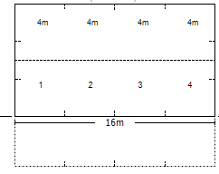
3D: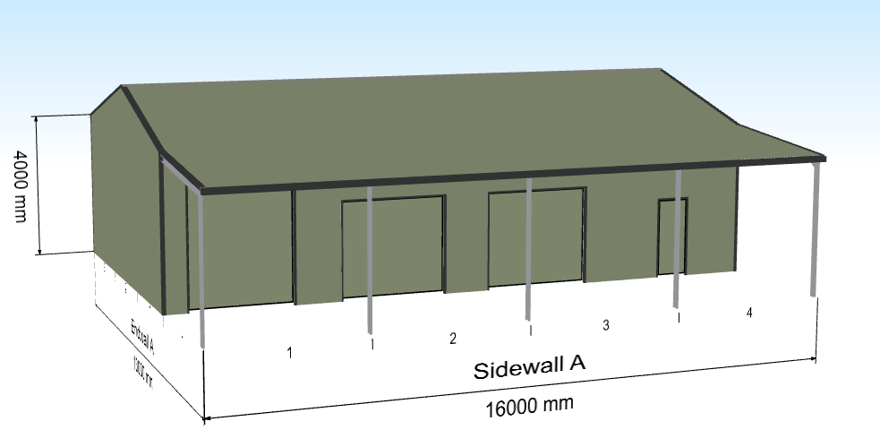

DESCRIPTION OF DEVELOPMENT
PROPOSED STRUCTURE | 9m x 16m x 4m with open 4m lean-to
INTENDED USE | Housing of vehicles and caravan
COLOURS
LAND ZONING | R1- General Residential
LOCATION/SET BACKS | 2m from northern boundary 29.71m from western boundary 25.4m from southern boundary
DEMOLITION | Nil
EARTHWORKS | No more than 0.5m – all excess to be distributed on site
TREE REMOVAL | Nil
STORMWATER | Connected to new water tank

Access and traffic
- Increases to traffic movements is not anticipated
- Construction will be carried out during daylight hours only

- All waste materials to be sent to an licenced off-site facility

Air and Noise

- There will be minimal additional noise associated with the development.
- All construction will be during daylight hours
- There is ample room for on-site parking of work equipment and vehicles

Visual impacts

- The shed will have no impact on the neighbouring properties.

Other environmental considerations

- The development is deemed to comply with the relevant NSW Environment Policies
- No constraints are envisaged and the site has been deemed suitable for the proposed development.
- We assess the likely environmental impact of the development to be minimal.

Should you require any further information please contact either myself or the owner.

Regards,

Lynn Smith
MA Steel 02 6382 4387 on behalf of

